**RECEIVED PRONUNCIATION**

Received pronunciation, commonly abbreviated as RP, is a once prestigious variety of [British English](https://www.thoughtco.com/british-english-bre-1689039) spoken without an identifiable regional [dialect](https://www.thoughtco.com/what-is-accent-speech-1689054). It is also known as British Received Pronunciation, BBC English, the Queen's English, and posh accent. [Standard British English](https://www.thoughtco.com/standard-british-english-1692136) is sometimes used as a synonym. The term received pronunciation was introduced and described by [phonetician](https://www.thoughtco.com/phonetics-definition-1691622) Alexander Ellis in his book "Early English Pronunciation" (1869).

**Characteristics of RP**

Not every dialect in Britain has a pronounced h sound, which is one difference between them, among differences in vowels. "The prestige British accent known as 'received pronunciation' (RP) pronounces *h* at the beginning of words, as in *hurt*, and avoids it in such words as *arm*. Cockney speakers do the reverse; *I 'urt my harm*," explained David Crystal. "Most English accents around the world pronounce words like *car* and *heart* with an audible *r*; RP is one of the few accents which does not.

In RP, words like *bath* are pronounced with a 'long *a*' ('bahth"); up north in England it is a 'short a.' Dialect variations mainly affect the [vowels](https://www.thoughtco.com/vowel-sounds-and-letters-1692601) of a language." ("Think on My Words: Exploring Shakespeare's Language." Cambridge University Press, 2008).

**Passive vocabulary**

Passive vocabulary refers to words that learners understand but are not yet able to use.

**Active vocabulary**

Active vocabulary, on the other hand, is the words that learners understand and use in speaking or writing.

**Difference between Active and Passive**

The **main difference between active and passive vocabulary** is that active vocabulary is the words you understand and use, while passive vocabulary is the words you understand but don’t use.

You encounter the concepts of active vocabulary and passive vocabulary in language learning. Both these refer to the words you know, but their difference is in their usage. In any language, passive vocabulary is larger than active vocabulary. This is true for both language learners and native speakers of a language.

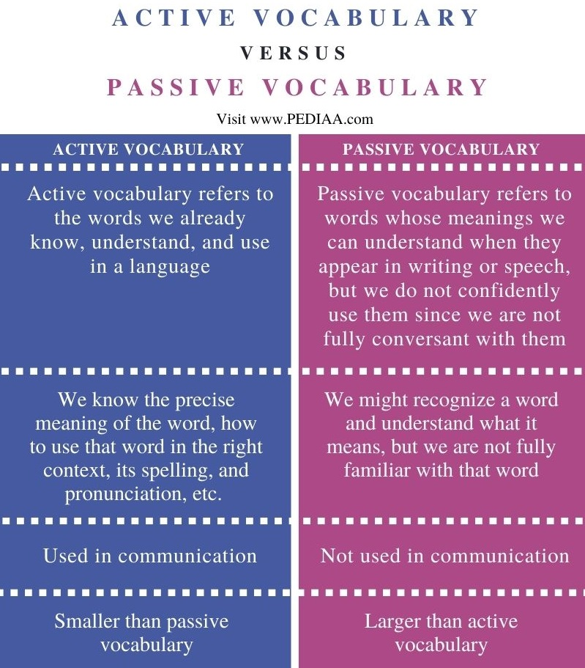

**How to activate passive vocabulary**

1. **Ditch the Dictionary**

What do you do when you’ve forgotten the words you need to express your thoughts in Chinese, Spanish or whatever language you’re learning?

And what do you do when forgetting a word in your mother tongue?

**That’s right:** You’ll describe its meaning or use a synonym. You don’t stop to open up a dictionary.

We think of enriching our mother tongue vocabulary only when wanting to impress someone, sound smart or beef up a written piece with better language. Only in these situations might we stop to look up a word or two. Most of the time, we find clever ways of talking or writing our way around the missing vocabulary word.

Do this in your foreign language rather than running for the dictionary every time you’re missing a word, and your brain will get more adept at searching for the vocabulary you need—and in the worst cases, you’ll get better at describing things and maintaining the flow of conversation.

**2. Smooth Path**

Before you start expanding vocabulary, **prepare a place** for new words in your mind and speech. That is to say, smooth the path.

Until now, you’ve probably used one common trick when trying to express thoughts but stumbling at verbalizing them: You adopt **plague words** to fill the gaps.

For example, let’s take plague words such as *very* and *really.*Instead of learning more specific synonyms, we attach these to other words. We can say *very big* instead of *huge*, or*very, very big* instead of *enormous*or *gigantic*. We can say the universal, nondescript word *thing*and use it as a substitute for tons of other words, rather than actually having to think of more specific, descriptive vocabulary.

Now, think of which plague words you might be leaning on too much in your foreign language of interest.

To expand your active vocabulary, say “no!” to your favorite word replacements. Don’t simply paraphrase or plagiarize from others, and don’t be lazy about finding that particular noun or adjective to communicate your idea.

**How to figure out these words?**

* Re-read your messages with friends on Facebook, [WhatsApp](https://www.fluentu.com/blog/whatsapp-language-exchange/" \t "_blank) or whatever messenger you use.
* Make a list of the words you often choose to fill vocabulary gaps.
* Give the list to a friend and ask them to scold you every single time you write or say mentioned words.
* Reward a friend with a dinner or wash their car whenever you use one-size-fits-all words 50 times. (With no sanctions or motivation, it will be difficult to get rid of that hoary vocabulary.)

After you learn to slow down a little for *very*, *thing*, *amazing* and any other favorite plague words, your memory will know that it can’t take the easy way out—and it will start to deliver synonyms from your passive vocabulary.

**3. Total Recall**

One of the most common pieces of advice for language learners is: *Write new word in a notebook or on flashcards.*

Even if you go about doing this, the problem is, words are difficult to remember without context.

Instead of reviewing a list of isolated words and phrases bereft of context, make strides towards practicing your words in context and visualizing them in real situations.

**GUESSING**

Guessing feels like you are taking a tiny risk that might be wrong when you are learning English.

Perhaps that is why you feel uncomfortable ‘guessing’ what things mean when you hear them in English or you feel afraid to say a word that seems right even though you have never heard it before. This is a natural part of learning English and having to take those chances trying to use English with real people.

## Building Confidence with Guessing Skills

Perfectionists will struggle to learn English (or any language) and suffer from low confidence.

They will be too busy trying to memorize verb tables and grammar to see the benefit of being incorrect or not understanding something perfectly.

Don’t lose sight of the real reason you are learning a language. It is to be able to communicate with people.

People do not always speak properly and you will continue to hear new words and phrases every day. Guessing will become a skill you need to use and be comfortable with.

Guess when you need to. It’s okay if you aren’t correct. You are still learning!

#### ****To successfully understand a sentence, follow this order:****

1. Use and apply the knowledge you already have about English. Don’t doubt it, it is likely correct!
2. Look up individual words you don’t know for their meaning.
3. If there are a series of words together that don’t make sense, check if it is a phrase by using a translator like using context.reverso.net.
4. If you still don’t understand the sentence or one part is hard to figure out… then use google translate.